**Creating Users and Managing Groups in Windows 10**

**How to create new users**

**Step 1**: Open the *Microsoft Management Console (MMC)* by typing *MMC* into the search bar in the bottom left corner of the screen. Hit the **enter key**.

*Warning*: a User Account Control window may appear, this is OK! Click **Yes**  to run the MMC software.

**Step 2**: Open the *Add or Remove Snap-ins* window by clicking **File** in the top left corner of the MMC then **Add/Remove Snap-in** from the dropdown menu, or simply press the **Ctrl** + **M** keys at the same time:

**Step 3**: In the menu located directly below “Available snap-ins:” scroll down to find the **Local Users and Groups** snap-in, then double-click it. This will open a new window titled: *Choose Target Machine.*

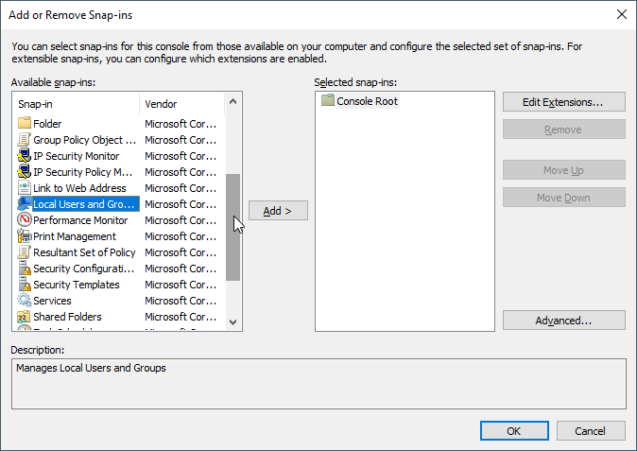

**Step 4:** In this new window, ensure “Local computer:” is selected. Click **Finish**. Click **OK** in the previous *Add or Remove Snap-ins* window:

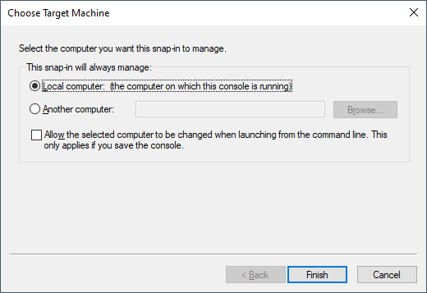

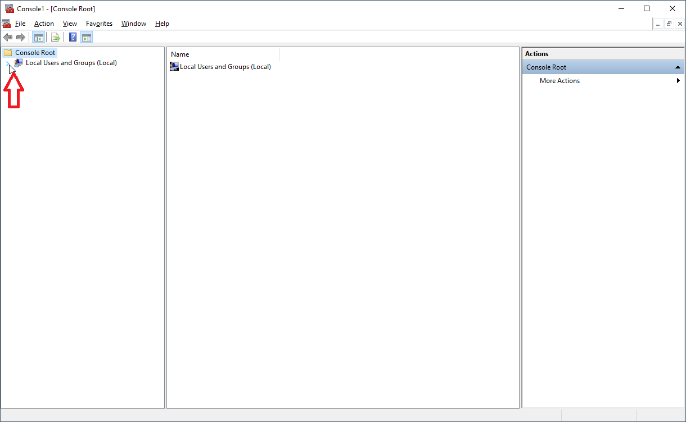**Step 5:** Click the **>** to the left of *Local Users and Groups (Local)* to view the *Users* and *Groups* files (see red arrow in image below):

**Step 5:** Click the **Users** folder to view a list of its contained users:

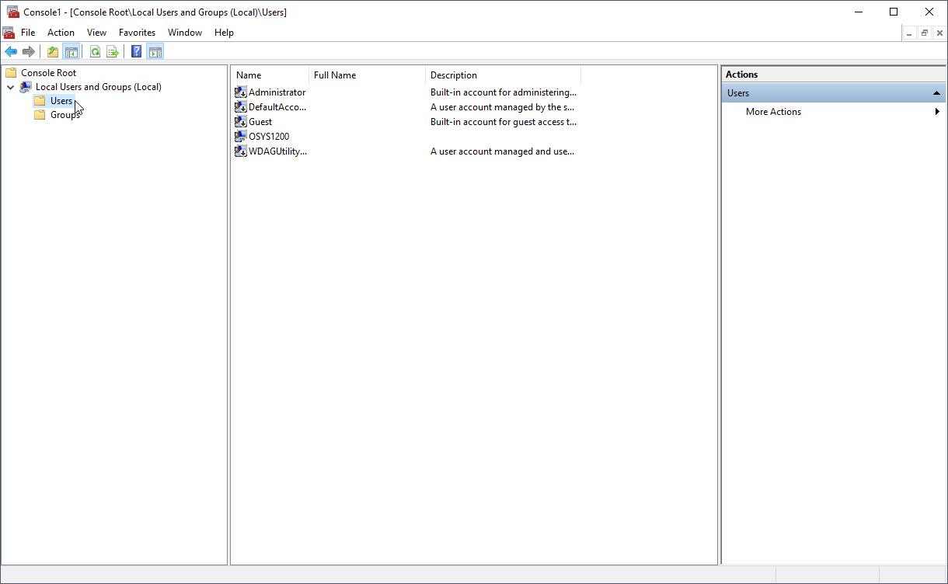

**Step 6:** Right-click anywhere within the white space below the list of contained users. Select **New User…** in the menu that appears:

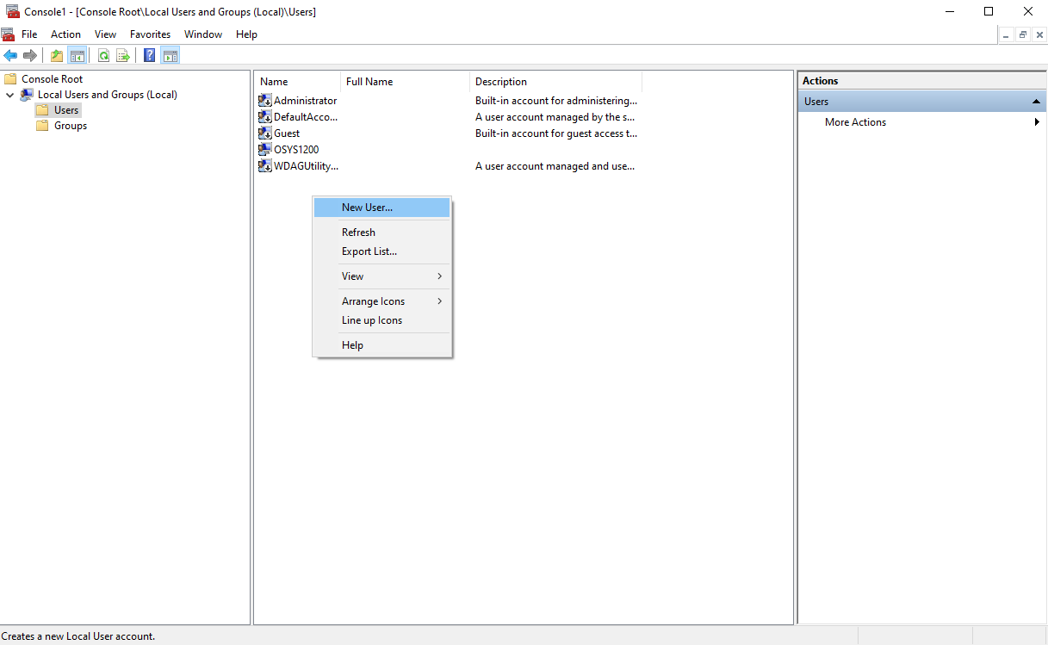

**Step 7:** In the *New User* window that appears, fill out the following fields: the new user’s *User name*, the user’s *Full* (real) *name*, and a *Description* of the user. Click **Create**. Repeat this process for the desired number of new users. Click **Close** once all new users have been created:

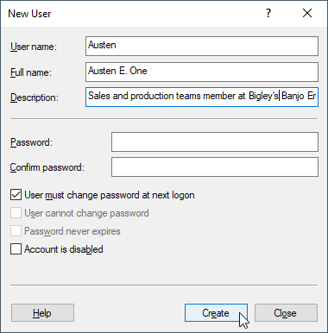

**How to create new groups**

**Step 1:** Click on the **Groups** folder located directly under the *Users* folder in the left-hand column of the MMC.

**Step 2:** Right-click anywhere within the white space below the list of group names in the center column. In the menu that appears, click **New Group…** to open the *New* *Group* window:

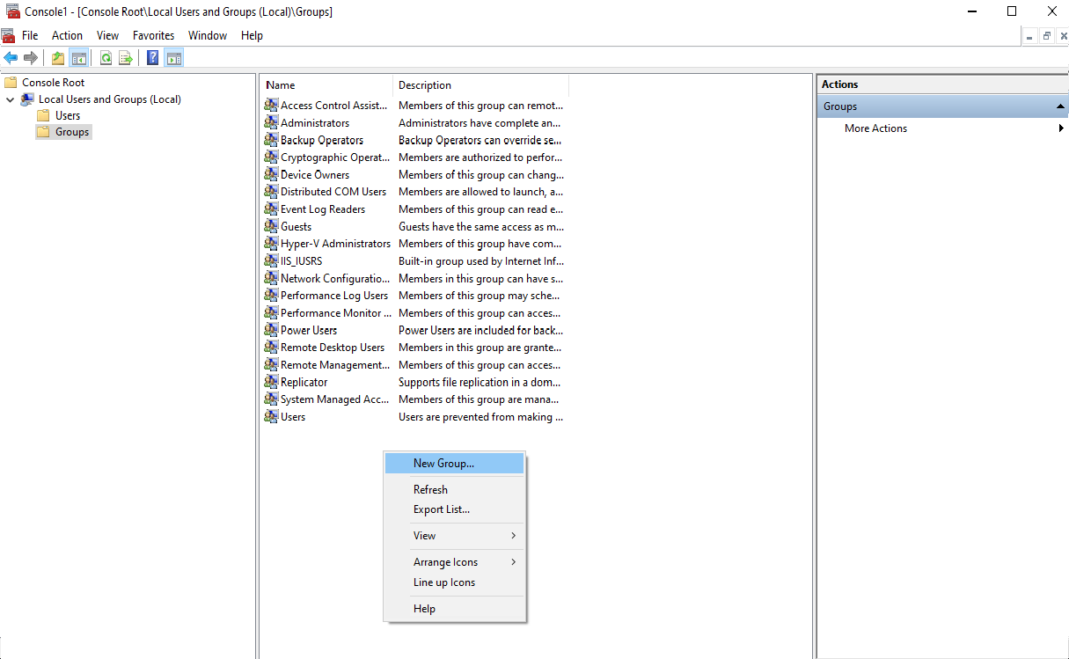

**Step 3:** In this new window, enter a *Group name* and *Description*. The *Members* (users) can also be added now by clicking **Add…** to open the *Select Users* window:

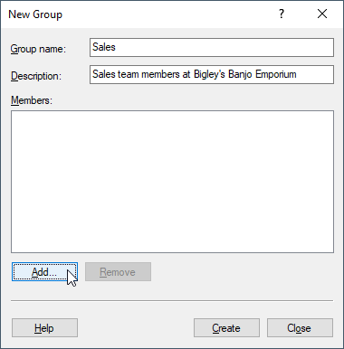

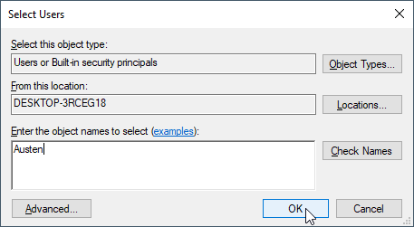**Step 4:** In this new window, enter the *User name* of the user that is to be added to the group. Then click OK. The process can be repeated for the desired number of members:

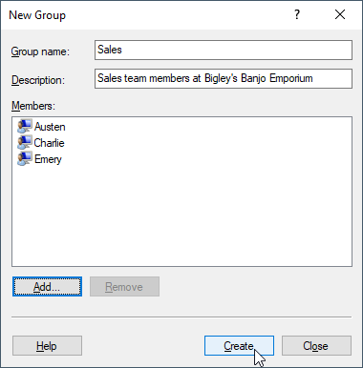**Step 5:** Once the desired number of users have been added to the group, click **Create**:

**Step 6:** Repeat **Steps 3 – 5** to create the desired number of groups. Click **Close** once all groups have been created.

**Assigning users to multiple groups**

As an alternative to adding users to a group at the time of the group’s creation (**How to create new groups - Step 3**), users can be added to multiple groups at once from the *Users* folder.

**Step 1:** Open the *Users* folder in the left-hand column to view the list of Users contained.

**Step 2:** Double-click the User (or right-click the User and choose **Properties**) to open the *[User] Properties* window.

**Step 3:** Within this window, click the **Member Of** tab:

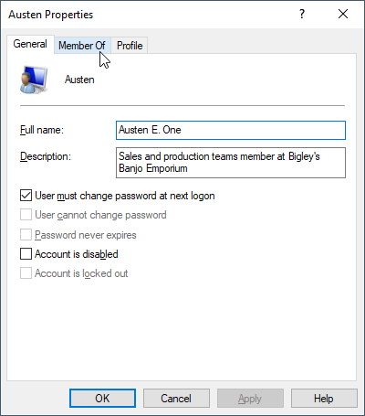

**Step 4:** Within this tab,click the **Add…** button located at the bottom the window:

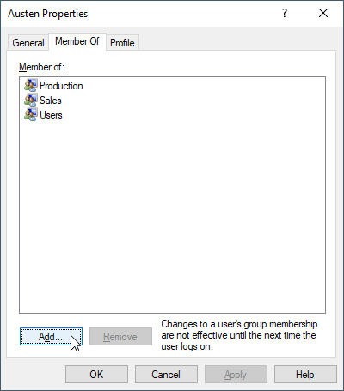

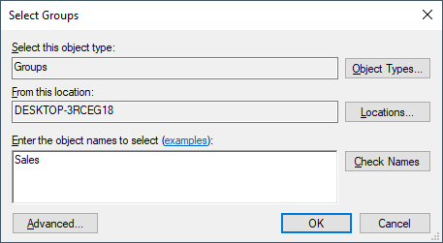**Step 5:** Enter the name of the Group to which the User will be added, then click **OK**. Repeat steps 4 and 5 to continue assigning the User to multiple groups